The 2014 Rotary Convention – Sydney, Australia
(An attendee’s perspective by Klaus Hachfeld)

Each year Rotary International organizes its 4-­‐day convention, typically early June, with the venue moving to a new location each year. Last year it was in Lisbon (Portugal), this year Sydney (Australia), then 2015 Sao Paolo (Brazil), 2016 Seoul (Korea) and 2017 Atlanta (USA). If ever you get the chance to attend, do it! It brings together a wonderfully diverse assembly of people from all over the world, young and old, all of them friendly.

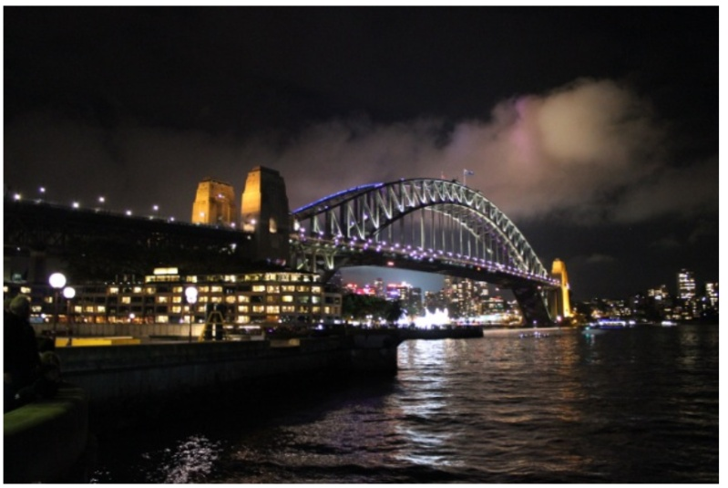
This year the attendance was typical, more than 18,000 Rotarians, Rotaractors, Interactors, and Rotary Foundation Alumni. Besides the core convention program, there are additional events like the Rotaract pre-­‐convention, the Rotary Alumni Celebration, the World Water Summit, and fun events that included the breaking of the Guiness Book of Records for the most people standing at the top of the Sydney Harbor Bridge; a fund-­‐raiser to help end Polio world-­‐wide.

My wife, Glenys, and I had attended six previous conventions and can tell you that this one was outstanding as much for its location as the program content. Sydney is one of the friendliest of places, with phenomenal train, light rail and ferry service to all parts of the city. The river system dominates the city, with superb tourist attractions at Circular Quay where Sydney Opera House is located, and Darling Harbor where the musical fountains and restaurants are a big draw.

Sydney is ALIVE, and showed us its imagination with the month-­‐long Vivid Festival while we were there. At that time the Opera House and many major building were dynamically illuminated with exotic designs and laser projections. As a laser-­‐junky, I was impressed with the laser projected 3D ballet dancers cavorting in the spray from a water fountain in Darling Harbor. You get the picture; it was pure magic!

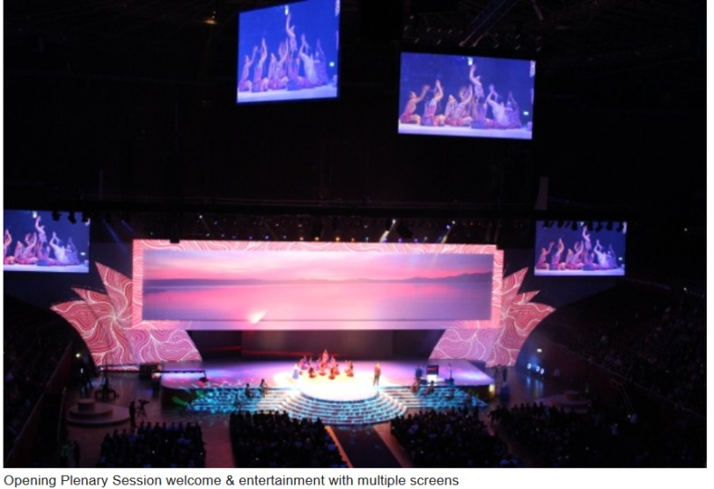
Oh yes, the convention. Hmmm. All the Rotary programs were in buildings in Olympic Park, built for the Year 2000 Olympic Games. One day the Olympic flame was lit, which tempted a few Rotarians to jump into the space below the flame while surrounded by waterfalls. OK, I know, you need to have been there at the time!

The plenary sessions, particularly the opening and closing sessions make your hair stand on end. Think in terms of 18,000+ Rotarians filling the many levels of a major arena, with huge state of the art audio/visual multiple screens making visible all the action on the stage.

You could also spend time at the House of Friendship and cuddle a live Koala Bear, check out the Wombat, watch great live musical entertainment, eat, relax, talk with Rotarians from everywhere, then spend your money on Australian opals and endless “Rotary stuff” at the hundreds of booths showing product and displaying Rotary projects. It also proved to be a good place to talk with attendees about RAAGNE, give them the RAAGNE contact cards and encourage their District leaders to get engaged with us.

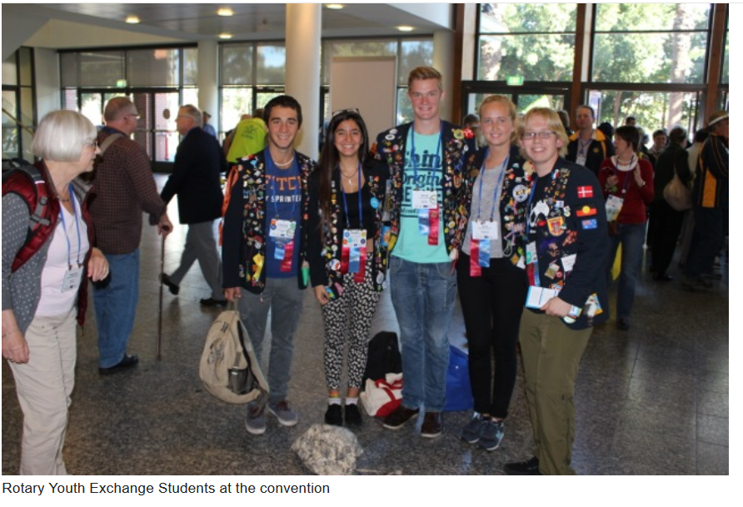
There we met and talked with Evan Burrell, who runs an e-­‐club in Australia. Specifically we explored the opportunities to expand the RAAGNE website so as to also provide alumni the opportunity to participate in webinar meetings from anywhere in the World, as per a visitor to an e-­‐club. He is willing to work with us.

We attended the Alumni Celebration, a morning of presentations including one by Ms. Maya Ajmera, an Ambassadorial Scholar Alum and recipient of the 2013-­‐14 Global Alumni Service to Humanity Award. I talked with Maya because she created an organization that guides and supplies funds to small self-­‐help communities, so she is willing to give us some guidance as well. I mentioned RAAGNE’s first project supporting a girls’ school in Afghanistan. This Celebration gave us another opportunity to promote RAAGNE as we distributed cards and talked with attendees.

Dr. Bruce Aylward of the World Health Organization presents the latest progress report on the Eradication of Polio at each Rotary Convention. We had heard him speak several times over the years and found it fascinating as he told of the twists and turns the three types of Polio have taken. Rotary has been spearheading the eradication for 25 years and the effort is clearly coming to an end, provided political and religious factions will allow the immunizations to continue.

Prior to and during the convention, we were generously hosted in the home of a Rotary Club president. What a super way to get to know Rotarians the other side of the World and compare notes! Also one evening in common with many other clubs, his club hosted several convention attendees for an evening and dinner. You have to experience this to realize what an amazing organization Rotary is.

Would we go to another Rotary Convention, or is seven enough? Well we are really not convention junkies, but I can see myself saving pennies to go some other time. Where else can you find such a positive spirit of cooperation and meet so many people doing extraordinary things to help others?

Klaus Hachfeld, PDG District 7910, USA

